POWER PASSION PURPOSEINC
Repairer of Brokenness with Love, Support, & Understanding
TIN: 82-2822460

2023 Sponsorship Levels
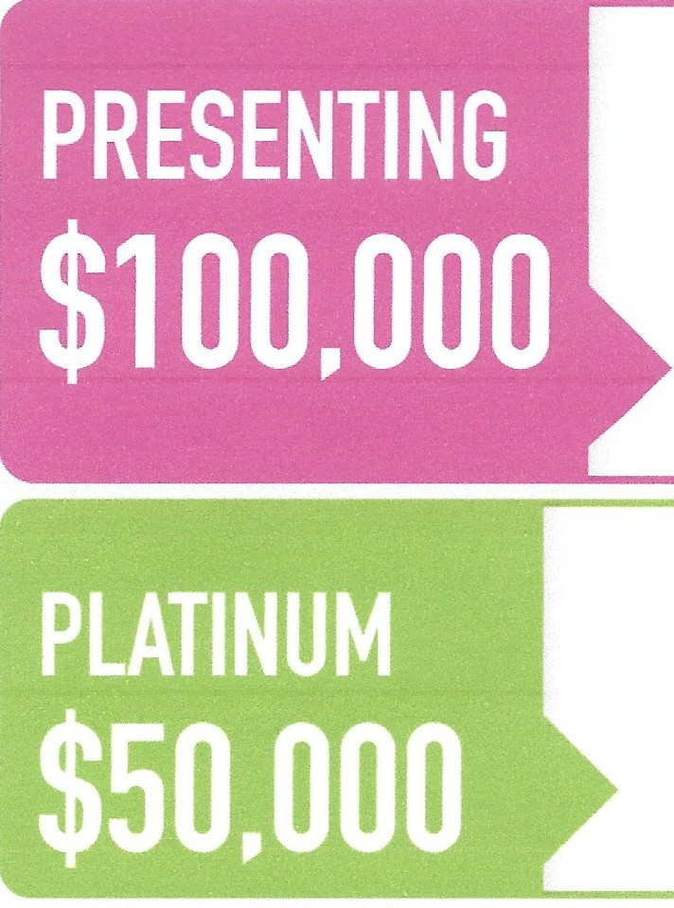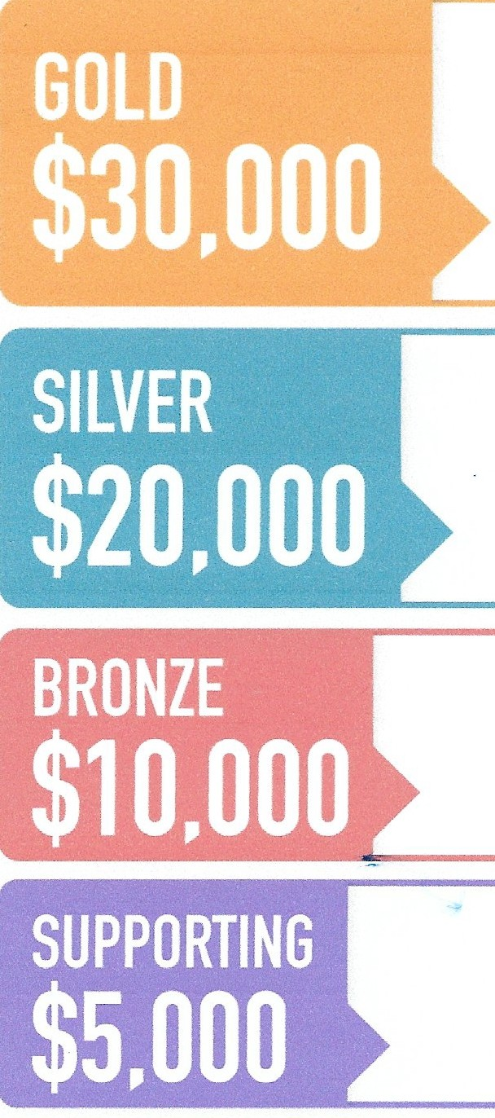
- Presenting sponsor at Power Passion Purpose Annual Gala / Retreat
- 2 VIP tables (for 10) at Gala - $10,000 value
- 5 nominations for the Power Passion Purpose Woman of the year Awards
- 3P’s Sister Circle “The BEAUTIES” Memberships for all employees
- Partner with 3P’s on sponsored research project
- National branded program
- Marquis Presenting sponsor logo placement on all 3P’s signage at events
- Everything in Supporting sponsor level

- Platinum sponsor at Power Passion Purpose Annual Gala / Retreat
- 2 VIP tables (for 10) at Gala - $10,000 value
- 4 nominations for the Power Passion Purpose Woman of the year Awards
- 3P’s Sister Circle “The BEAUTIES” Memberships for all employees
- Customized corporate chapter events
- Platinum sponsor with premiere logo placement on all 3P’s signage at events
- Everything in Supporting sponsor level

- Gold sponsor at Power Passion Purpose Annual Gala / Retreat
- 1 VIP table (for 10) at Gala - $5,000 value
- 3 nominations for the Power Passion Purpose Woman of the year Awards
- 3P’s Sister Circle “The BEAUTIES” Memberships for 100 employees
- Gold sponsor with premiere logo placement on all 3P’s signage at events
- Everything in Supporting sponsor level

- Logo exposure on all 3P’s signage at events
- Logo on 3P’s website, eblasts and all marketing material
- Power Passion Purpose Gala exposure - Digital Tribute Book ad and product placement in gift bags

- Bronze sponsor at Power Passion Purpose Annual Gala / Retreat
- 2 tickets to Power Passion Purpose Gala - $600 value
- 1 nomination for the Power Passion Purpose Woman of the year Awards
- Everything in Supporting sponsor level
- Silver sponsor at Power Passion Purpose Annual Gala / Retreat
- 4 tickets to Power Passion Purpose Gala - $1,200 value
- 2 nominations for the Power Passion Purpose Woman of the year Awards
- 3P’s Sister Circle “The BEAUTIES” Memberships for 50 employees
- Silver sponsor with premiere logo placement on all 3P’s signage at events
- Everything in Supporting sponsor level

Don't see what you're looking for? Let's talk customization

Please make all checks payable to:

Power Passion Purpose, Inc.
Mail to: c/o Tisha Dolby
14335 Ella Blvd. #1411
Houston, TX 77014
CORPORATE MEMBERSHIP PACKAGES
- Less than 10 employees - $750
- Less than 25 employees - $1,000
- Less than 100 employees - $1,500
- Greater than 100 employees - $5,000

For information and questions, please contact:

Walter Denson at walter.denson@ppp-inc.org or
LaMeka-LeShe Dolby at lameka_leshe.dolby@ppp-inc.org

